First project with Netbeans.
Install openjdk-11-jdk and Netbeans 11
sudo add-apt-repository ppa:openjdk-r/ppa
sudo apt update
sudo apt install openjdk-11-jdk
java -version
---
sudo snap install netbeans --classic
To start a project with Netbeans we will follow the next steps
1. Menu File| New Project
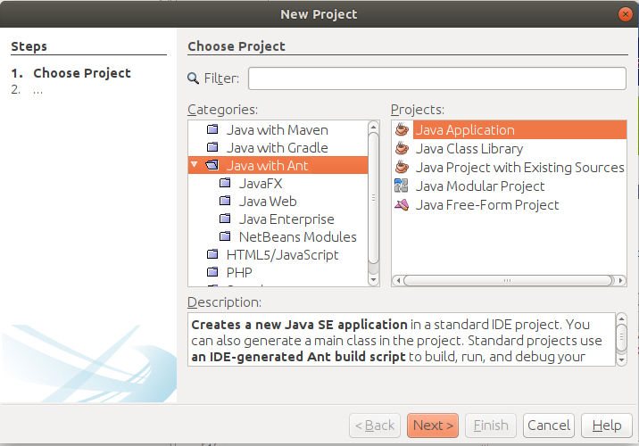
2. Next:
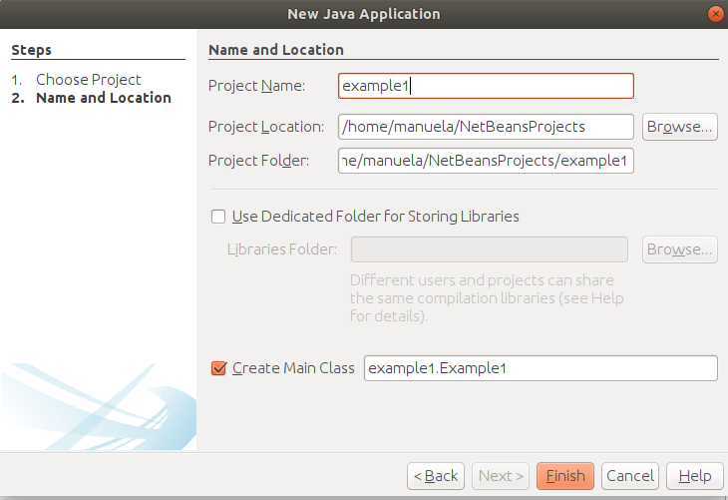

The project´s name will be example1 and it will be saved in the rute “Project Location”, now we will click Finish:
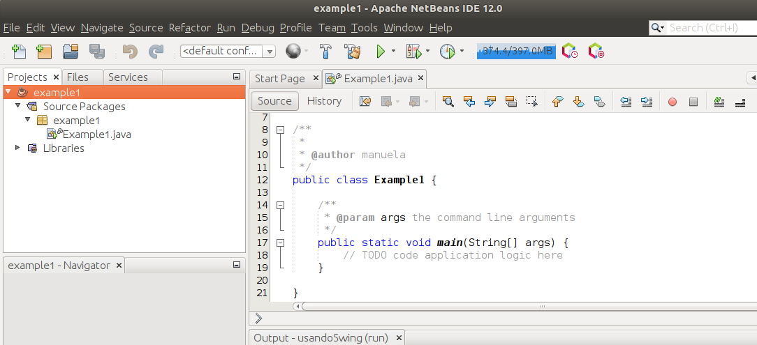

Then we will write the code in the main method:

Then we execute the project:

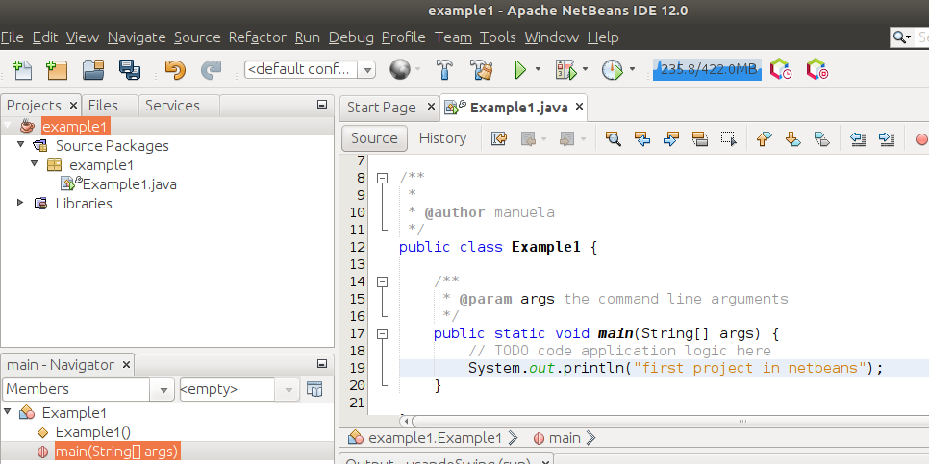

And this gives as a result:

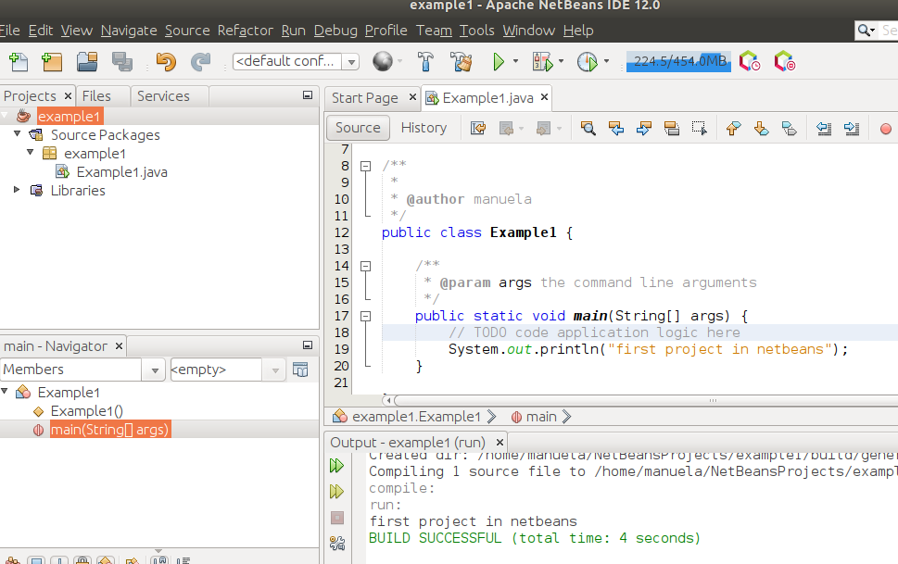

Save the project as menú File | Save if you didn´t do it before.
The java files will be in the following folder
